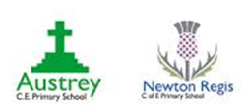**Austrey and Newton Regis CE Primary Schools**

**Respecting the Environment in our Curriculum**

**(Stewards of the Earth)**

**Becoming the person God made me to be: living, learning, loving.**

*“I praise you because I am fearfully and wonderfully made”* Psalm 139:14



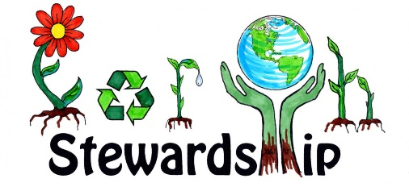 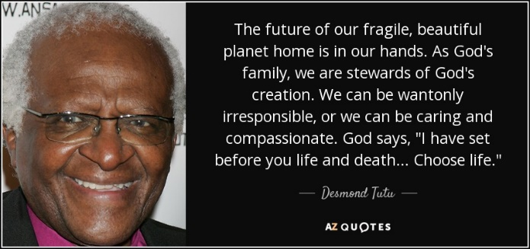 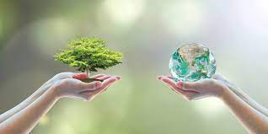

**Our Vision**

Austrey and Newton Regis Church of England Schools are small schools at the heart of their rural communities. They have a living Christian foundation that follows the teaching and example of Jesus who reached out **in love** and drew in everyone, whatever their status or struggles, beliefs or views.

Created to be like God, we are all individual, different, and precious. As school families,we treat everyone with **dignity**, seeing each person as a vital stroke in the creation of the masterpiece which is our school **community.** We **love** and welcome everyone, supporting them in the ups and downs of life and giving them **hope** for a bright future in their lives and **learning**. **Living** like Jesus, we think and act with **generous** and **forgiving** hearts in the strategic and day to day life of the schools, so that everyone can flourish. **Trusting** in God and the teaching of the bible, we are building a culture of **trust** in which everyone can feel safe; confident that their spiritual, emotional and academic needs will be met and that their **uniqueness** will contribute to the **unity and wholeness**of Newton Regis and Austrey Church of England Primary Schools.

**Our Curriculum Intent Statement**

At Austrey and Newton Regis CE Primary Schools we take pride in providing a knowledge-rich curriculum that is inclusive and equitable, celebrates diversity and is relevant to our school: preparing children for the fullness of life in an ever-changing world

Respecting our Environment

|  |  |  |  |  |
| --- | --- | --- | --- | --- |
|  | EYFS | Year 1/2 | Year 3/4 | Year 5/6 |
| English | David Attenborough  Commotion in the Ocean  Raindrop  A Planet full of Plastic  Once upon a Raindrop | Blue Planet  Savannah  Bog Baby- making mini beast habitats  10 things I can do to change the world – Leaflet on recycling | Natural disasters  Non-chronological report- Deserts  ( desertification) | Varmints- Global Warming  Effects of housing developments on local environment  Non-chronological report on Arctic and Antarctica- Including environmental impacts  River and Deserts- Impact of building on flood plain  Galapagos and Darwin’s journey |
| Science | David Attenborough  Jabari tries  Leapard’s Drum  Handas Surprise  Recycling  Forest Friday- Looking at our environment and the changing seasons  Exploring using all the senses | Environmental impacts on food chains  Benefits of planning trees to our environment | How humans have impacted the Ocean  Threats and dangers animal species in the ocean  Bleaching of Coral reefs | Environment impacts on life cycle of a darkling beetle  Deforestation  Harmful effects of microorganisms  Decaying- Composting  Changes in Arctic/ Antarctic environment and the impact on animals  Selective Breeding on production – intense farming and the impacts  Do you think that electricity is the best invention> Renewable energy and impact of power stations |
| Geography | David Attenborough  Changes in Seasons- Forest Friday  Handas Surprise  Leapard’s Drum | Coastal Erosion  Conservation | Environmental changes to the Oceans  Oil Pollution | Deforestation  Flooding of the Nile- impact on the environment  Forestry Commission  How animals adapt to the environment> Moths changing due to pollution of the industrial revelation |
| History | Thinking of lives in the future and in the past. How can we help make the world a better place? How did people in the past help us?  So Much |  |  |  |
| PSHE | David Attenborough  Hello Friend |  |  | Me and My World- Global community  Dreams and Goals for our World |
| Art and DT | Transient natural art | Recycling – match work mini beast blanket | Design a natural disaster shelter out of recycled materials |  |
| Computing | Purple mash Activities | | | |
| RE | Which places are special? | Who made the world? W | Creation- Deciding what is right and wrong? | Creation- Looking after our Beautiful planet- The importance of preserving what we have |
| SCHOOL COUNCIL | 1. All classes to have two bins in classroom- Recycling paper 2. Fruit waste composted 3. Paper to us again trays 4. Does it have to be on a new piece of paper? Raise awareness 5. Spirituality garden- environmental art- | | | |