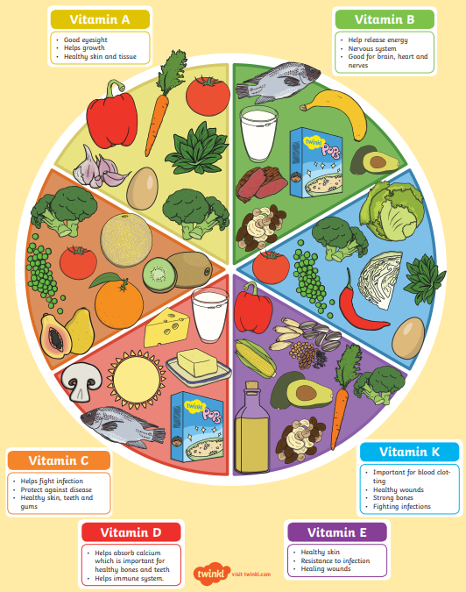
Nutrition
What is a balanced diet?

A balanced diet involves drinking enough water and eating the right amount of foods from the different food groups.
What are carbohydrates?
They provide the energy to perform the important functions of the body and keep it active. These include bread, rice, pasta and potatoes.

What is protein?
They help in the development of organs, tissues and muscles in the body. They support the growth and functioning of the body. Foods high in protein include eggs, meat and fish.
